Automatic Double Sides Labeling Machine

PM-660 Operating Manual

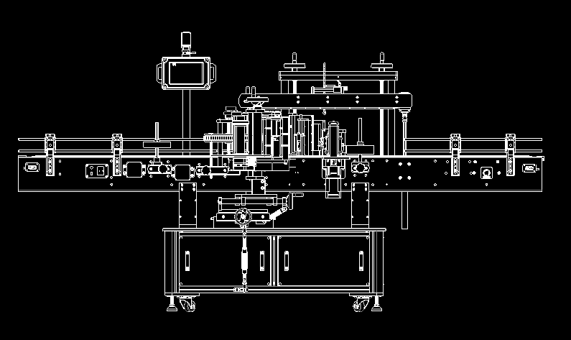

Catalogue
Chapter 1 Preface 4
Chapter 2 Safty Tips 5
Chapter 3 Technical parameter 6
3.1 Drawings 6
3.2 Label size 7
3.3 Power supply 8
3.4 Coding machine (optional accessories) 8
3.5 Labeling speed 8
3.6 Application bottle type 8
3.7 Labeling accuracy 9
Chapter 4 Install 9
4.1Adjust the height and level of the machine 9
4.2 Connection of the electrical box and control box 10
4.3 Connection of power supply 10
Chapter 5 Function description and troubleshoot 10
5.1 Description of the Control MENU on touch screen 10
5.2 Adjustment of protection fence 14
5.3 Adjustment of labeler 15
5.4 Label installment 16
5.5 Tightness adjustment of the label paper 16
5.6 Adjustment of electric sensor 17
5.7 Adjustment of electric sensor for label 17
5.8 Adjustment of coder position(optional accessory) 19
5.9 Adjustment of bottle feeding device 19
5.10 Adjustment of bottle separate interval 20
Chapter 6 Basic operation and use 20
6.1 Basic operation and use 20
6.2 Example 21
Chapter 7 Main Points of Simple Malfunction and Elimination Methods 22
7.1 Malfunction1:No power supply 22
7.2 Malfunction2:Conveyor belt is out of work 23
7.3 Malfunction3: 24
7.4 Malfunction 4: No outputting of label 25
7.5 Malfunction5:Label wrinkling 26
7.6 Malfunction6:Outputting label all the time 26
7.7 Malfunction7:Outputting several labels in a time 27
7.8 Malfunction8:Label paper broken when labeling 27
7.9 Malfunction9:Length of label is different 28

Chapter 1 Preface
The body of the labeling machine widely adopts anodized aluminum and 304 stainless steel, making the overall structure of machine firmer and more durable.On the mechanical properties, modular and user-friendly design adopted to make it easier for high-speed adjustment and changing types.Adopting man-machine interface control, easy to understand and operate. Superior circuit design makes the labeling speed of the machine leading international level.The machine completely adopt a new design concept to develop, it’s not only reduce the adjustment of mechanism, but also improve the accuracy and speed of labeling.
The detail description for operating the machine,please refer to follows.

Attention:
Please in strict accordance with the instruction during using and maintenance procedures.It is forbidden to disassemble during the warranty,otherwise, the damage caused thereby will be regarded as artificially damage and we will not provide free maintenance. If still have unclear points of operating the machine, please feel free to contact our company.

Chapter 2 Safty Tips
Before turn on the power of the machine, please read the safty tips and the right operating instruction on these manual carefully to avoid accidents and reduce the frequency of the damage to machine.

- Keep the machine away from the corrosive environment and avoid direct contact with corrosive chemicals.
- Avoid using the machine in vibration environment
- Please don’t touch the running machine parts when the machine is running.
- Avoid closing to high temperature environment and inflammable.
- Avoid using the machine in excessive moisture environment,connect the input power supply ground wire correctly to avoid accident.
- The operating workers should operate machine in a normal mental states,If take such as alcohol,sleeping drugs, or other drugs which damage to mental state, the workers should stop to operate the machine.
- The worker should put on suitable work clothes, avoid the clothes to get involved in the rolling parts of the machine. Don’t place any extraneous items on the machine.
- If there are noise and other abnormalities, please stop the machine immediately and check.
- Non-engineering and technical personal, don’t debug the machine parts arbitrarily.
- Regular maintenance and upkeep. Please avoid the water and other liquid splashing at the electronic control box and other electric components.
- Please follow the normal operating procedures for the operation, keep exterior surface clean.
- Coding machine installed on the labeling machine can’t operate alone,It must be synchronized with the labeling machine.

Chapter 3 Technical parameter

3.1 Drawings
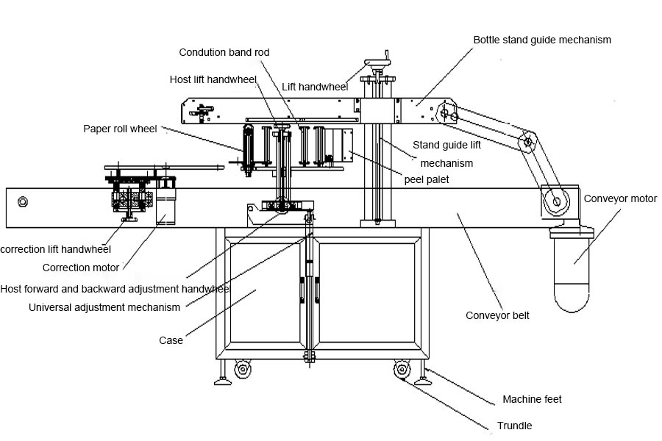
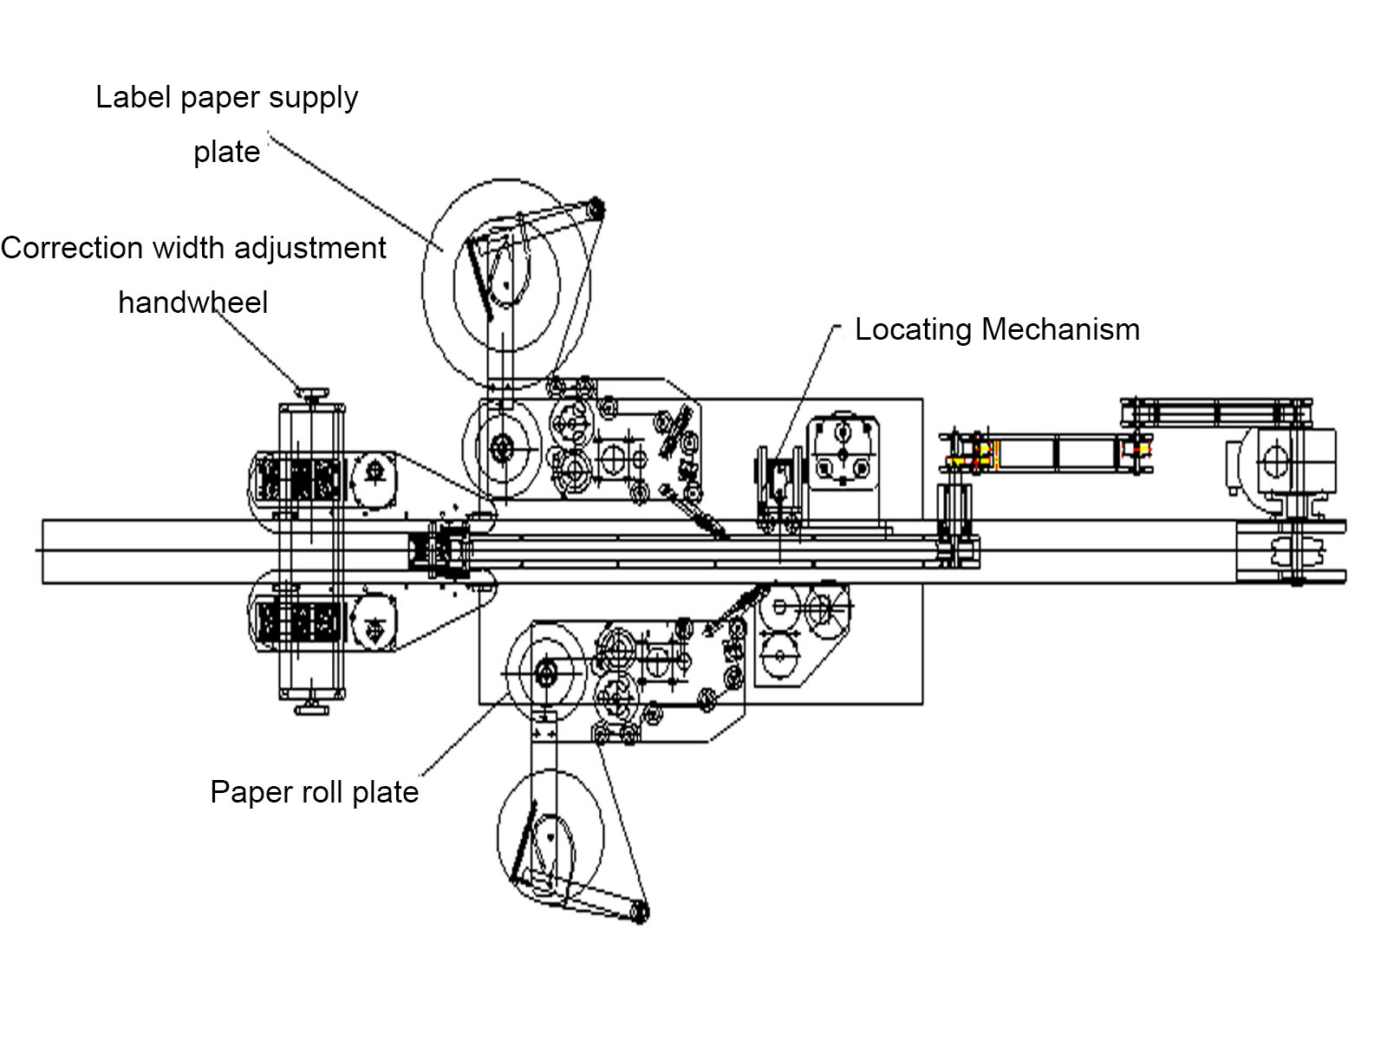

3.2 Label size
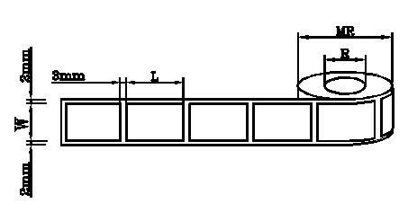
Please left more than 3mm gap between the labels for the electric eye detecting.
Material of under paper | Translucent paper
Paper pipe inner diameter | 76mm(custom size available)
Label outer diameter | 100mm~350mm(custom size available)
Width of the label | 10mm~130mm(custom size available)
Length of the label | 15mm~300mm(custom size available)

3.3 Power supply
Power: 220V(±2%) 50/60Hz single phase,3KW

3.4 Coding machine (optional accessories)
DL-7 hot code printer, Speed:0-100times/minute
Details please refer to the code printer instruction book.

3.5 Labeling speed
0~27m/minute

3.6 Application bottle type
Suitable for flat, square,oval,cylinder and other special shape container.

3.7 Labeling accuracy
±1mm

Chapter 4 Install

4.1Adjust the height and level of the machine
Height adjustment:unscrew the top bolt to adjust the height, recommend to use a jack as supporting.
Conveyor belt level adjustment:adjust level by base bolt,recommend to use leveling instrument for measurement.
Bottle feeding device adjustment(for 660B machine):adjust the screw foot at the same level with the transmission, in which standard that round bottle can transition to the conveyor belt smoothly.
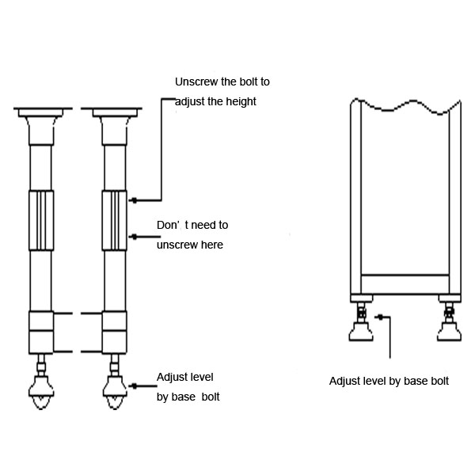

4.2 Connection of the electrical box and control box
Connect the plugs /group sockets of electrical box and control box according to number of pins within the connector，the sensitive electronic sensors is also connected and the electrical apparatus must be earth or grounded

4.3 Connection of power supply
Connect the main power supply according to specifications of electrical devices，if the power supply fluctuation is too much, a voltage regulator should be installed before the supply to the main equipment . All power supply must be properly connected to earth.

Chapter 5 Function description and troubleshoot

5.1 Description of the Control MENU on touch screen
There are total three menu on touch screen.
First: Operation language selection
Second:Operation and parameter settings
Third:Label installation
Detail description as follows:

Menu One

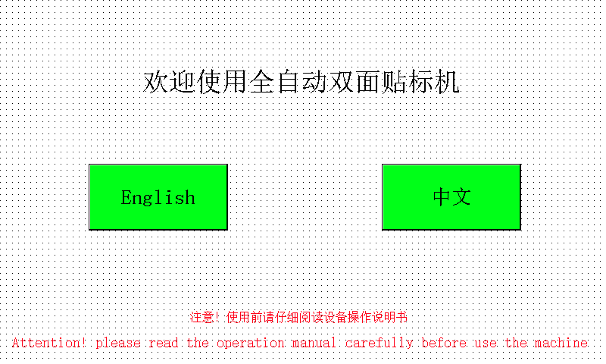
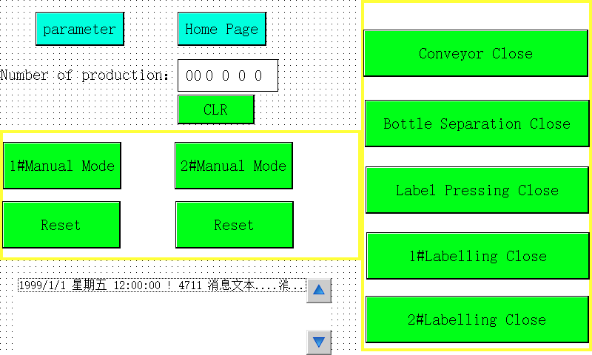

Touch Label winding diagram to enter the third menu.
Menu Two

Page Up: touch it back to the front page
Conveyor: touch it to start the conveyor belt, touch again to stop it.
Bottle Separate: touch it to make the bottle on conveyor divided and keep a suitable distance.
Bottle Pressing: touch it to have the sponge structure to press on the bottle after labeling and make the label stick tightly.
Parameter setting: touch it to adjust parameter.
Production Quantity：it shows the number of label output in a given period, can’t touch to alter.
Clear: touch it to return to zero.
1# label head off: touch it to stop the work of 1# label head working
2# label head off: touch it to stop the work of 2#label head

Menu Three

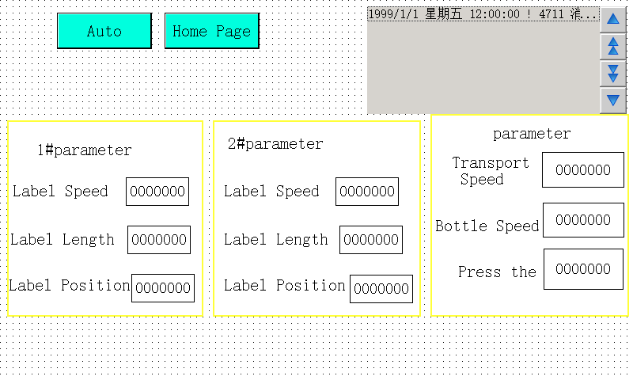
Labeling Speed: the value scope is 0-300, it’s proportional coefficient. The greater the value, the faster the speed, touch the number with finger can enter keyboard input way.
Length of labeling: the value scope is 0-999, it’s proportional coefficient. It’s the distance from head end of label to detect device of label,touch the number with finger can enter keyboard input way.
Position of labeling:the value scope is 0-999,it’s proportional coefficient.It’s the the time length from electronic eye inspecting object to start outputting label, touch the number at right side of labeling position with finger can enter keyboard input way.
Transmission frequency: the value scope is 0-99,it’s proportional coefficient. The higher the number, the faster the speed.

5.2 Adjustment of protection fence
In order to achieve the best result of bottle line,the adjustment should be carried out form the feeding direction, adjust it while the conveyor belt is running, it will achieve better result. Only need to loosen the adjusting knob,and then protection side guide according to required height and width,finally, lock the adjusting knob tightly.
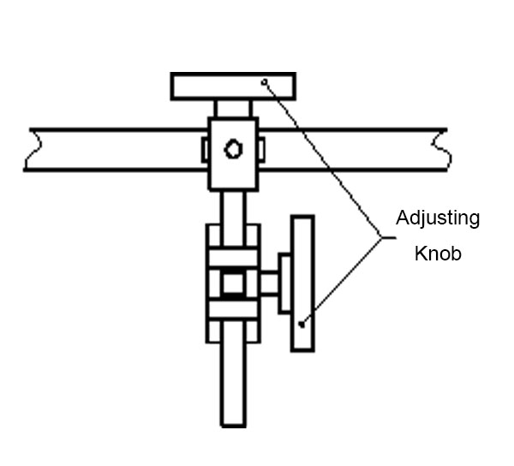

5.3 Adjustment of labeler
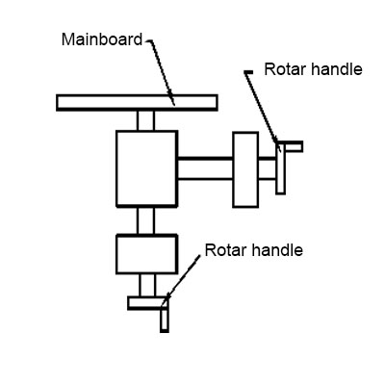
After adjustment of the protection fence, adjust the two turning handle as shown in the below picture, according to the height and position of labeling that the object can be labeled and pass through, and try to adjust to have a stable and smooth movement.

5.4 Label installment
Install the label as below picture(attention:Position A and Position B are the place easiest to install wrongly)
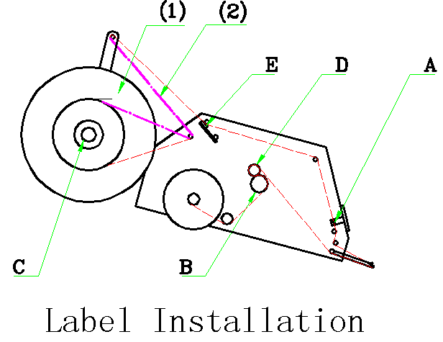

- :Label follows direction when label winding is on the inside.
- :Label follows direction when label winding is on the outside.
When install the label, please pull and loosen the label paper appropriately, tension the label paper with the turning wheel spindle C after installment.

5.5 Tightness adjustment of the label paper
Adjust positions of fillet wheel D and press plate E（refer to label installation diagrams DE）and then make label position of dispensing plate smooth as diagram.

5.6 Adjustment of electric sensor
(Normally, it has been adjusted before leaving factory.Users needn’t to adjust again)
The electric sensor adopts infrared reflective optical fiber. First, put the object in front of the head of the optical fiber; then turn the sensitive adjusting knob to the minimum in anti-clockwise direction;then turn the knob in clockwise direction until the indicating lamp lighted in yellow green,continue to turn in clockwise direction about 2 to 5 degrees. This is the optimum position and the standard is no secondary signal outputting when labeling object passes the electric sensor.
The position of electronic sensor should not be changed at discretion because it is relative with memory data.

5.7 Adjustment of electric sensor for label
(Normally, it has been adjusted before leaving factory.Users needn’t to adjust again)
- When there is no shade between the electric sensor, the running signal(yellow light) should remain lit. If not, please press”+” button to increase the sensitivity.
- When set the label (with backing paper)between the electric sensor, the running signal(yellow lignt) shouldn’t be light. If still light,please press”-”button until the yellow light be out.
- When take away the label(remain the backing paper), the running signal should light again,If not, please press”+”button to adjust a correct value.
- Pull the label straight between the electric sensor, and the pull the label paper, when the gap between the label through the electric sensor, the running signal will flicker.
- When finish all the above steps, please press the”+”button and ”-”button at the same time for 3 seconds to lock the state to avoid the mistake operation.
- If need adjustment again, please press”+” button or “-”button last 3 seconds to adjust according the above 4 steps.
- Please attention, there shouldn’t be multiple sensor point in a piece of label.It would cause of wrong output length of label. If need to adjust the position of the electric sensor, please also adjust other parameter.

5.8 Adjustment of coder position(optional accessory)
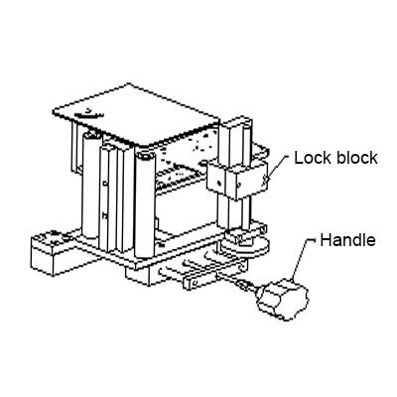
Adjustment of horizontal position: turn the rotary handle
Adjustment of vertical position:Loosen lock knob, open coder according to movable sliding track and move to required position and tighten up lock knob again.

5.9 Adjustment of bottle feeding device
Bottle feeding rod and bottle blocking rod: loosen the fixed hexagonal nut and or triangle knob to adjust the height and position. Observe if the bottle will not fall down and can transmit to the conveyor smoothly, and then fasten up.

Adjustment of feeding bottle speed: turn on the switch(on the feeding device),turn the rotary knob to the “high”direction to quicken the feeding speed,on the contrary, turn the rotary knob to “low” direction, the feed speed will slow down. Adjust the feeding speed to make the bottles keep a suitable distance.

5.10 Adjustment of bottle separate interval
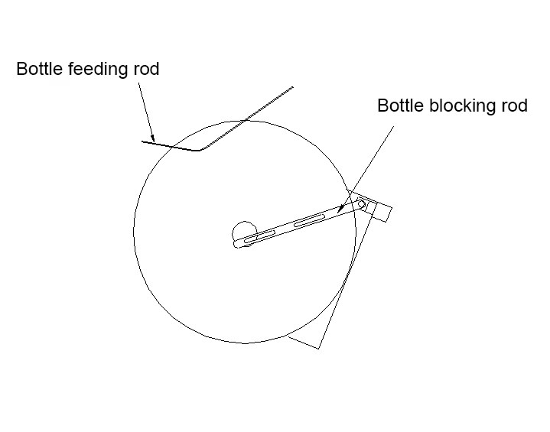
Firstly,adjust the protection fence and bottle feeding device,turn on the switch under the bottle separate device, turn the rotary knob to “HIGH” to decrease the distance between the bottle, on the contrary, the distance between bottles increases.

Chapter 6 Basic operation and use

6.1 Basic operation and use
Switch on the main power(located at the bottom of the conveyor belt), touch screen will appear the first menu after 1-2minutes.

Press the button of “Page down” to enter into the next menu. If need to input the target quantity,press the button of “Reset” to clear the quantity.

After enter into the second menu, confirm the quantity, the number means the number which needs to produce, press stop to start the belt. press stop labeling to start labeling. press stop print to start printing.

If it’s the first time to use the machine, please press the button of “page down” to enter into the third menu, in this page you can set the speed, position of print date and so on, detail operation please refer to the above chapters.

6.2 Example
Container dimension: diameter 54mm*L80mm Cylinder
Label size: 150mm*50mm
Position of the electric sensor for label:between the guide rail
Position of the electric sensor for workpiece:

Distance between the cylinder:150mm
Parameter input: Synchronous speed:200,
Length of labeling:65,
Position of labeling:30.
Labeling effect: Labeling speed；26m/min, about105pieces/min

Chapter 7 Main Points of Simple Malfunction and Elimination Methods

7.1 Malfunction1:No power supply

Is lamp bright after switching on？

Is fuse broken(No)
Electrical short circuit caused the power trip
Is the plug-in unit of power supply inserted properly?

Is touch screen light up?
Malfunction on switching power supply
Replacing fuse
Reconfirm power and wiring
Yes
Yes
No
No
Yes
No
Yes
No
Is Power supply switch on?

7.2 Malfunction2:Conveyor belt is out of work
Switch on power supply
Press page down to enter into Menu 3

Malfunction of speed regulation circuit
Is the conveyor speed zero?
Is it in motion when pressing（↑）to change conveying speed？
Does the driving parts of the conveyor have malfunction?
Malfunction of speed governor
OK
Eliminate it

No

Yes
Yes

No Yes

No

7.3 Malfunction3:
Switch on the power supply
Press Page down to enter into menu 3
Is the conveyor speed zero
Is it in motion when pressing（↑）to change conveying speed？

Does the driving part of the conveyor has malfunction?
Malfunction of speed regulation circuit
Eliminate it
OK
Malfunction of speed governor

No

Yes
Yes

No
Yes

No
No

7.4 Malfunction 4: No outputting of label
Yes
Electric sensor hasn’t scanned the workpieces or it’s not in motion
Line fault
Can the silicon wheel turn smoothly?
Labler is not switched on,or conveyor belt is not in motion
Move the position of electric sensor, or adjust the sensitivity of the electric sensor
Starting up and adjust the speed of conveyor belt
Driver of steeping motor is broken

No
Yes

No
Yes

No

7.5 Malfunction5:Label wrinkling
Fine turning the synchronous speed, be synchronous with the labeling speed
Find turning the synchronous speed, be synchronous with the labeling speed
The label slip back when labeling
Label wrinkling when labeling

7.6 Malfunction6:Outputting label all the time
No
Pull the label to inspect whether the electric sensor is in normal motion
Electric eye action incorrectly
(indicated light is blink)
Adjust the sensitivity of the electric sensor
Malfunction of label electric sensor
Adjust electronic sensor of label to scan action of base paper（clearance of labels），the label is failure to actuate when scanning it.

Yes No

Yes

7.7 Malfunction7:Outputting several labels in a time
Reset the length of label
Adjust the position or sensitivity of the electric sensor

Reset the sensitivity of the electric sensor
Setting of the label length is overlong
The electric sensor action several times when single workpiece through by

Yes

No Yes

No

7.8 Malfunction8:Label paper broken when labeling
Can the workpiece touch the stripping palet when moving on the conveyor
Is the embossing wheel or paper presser too tight?
Loosen the embossing wheel and paper presser slightly.
Contact with the label manufacturer and ask for improvement
Adjust the position of labeling mechanism or position of fence
The cutting trace of the label paper is too deep, or the tenacity of the label paper is not tough enough

7.9 Malfunction9:Length of label is different

Yes
Eliminate it

Label paper gets stuck or pressing screw on silicon wheel isn’t looked
Adjust the paper presser to press on label paper
Paper presser doesn’t press well
Reset the position of electric sensor, pull the label to confirm the electric sensor doesn’t have twice actions on one label.

No
Yes

No

Parameter of labeling machine (Factory setting)

1#Labeling Speed: 0--999 (200)
1#Length of labeling: 0--999 (20)
1#Position of labeling: 0--999 (10)
Transmission frequency:0-50HZ (40)

2#Labeling Speed: 0--999 (200)
2#Length of labeling: 0--999 (20)
2#Position of labeling: 0--999 (10)

