Automatic filling and sealing packaging machine

*Please pay attention to the direction of rotation of the motor before use
(run in the direction of the arrow)

Table of contents
1. Purpose
2. Structural features
3. Technical specifications
4. Operating Instructions
5. Matters needing attention
6. Adjustment method
7. Lubrication and maintenance
8. Analysis and elimination of common faults
Appendix 1: Air Purification System Description
Appendix 2: List of Consumable Parts
Appendix 3: List of random accessories
Figure 1: Structural diagram of YCXM-series filling and sealing machine
Figure 2: Schematic diagram of YCXM-series filling and sealing roll film placement
Attached drawing 3. Schematic diagram of the transmission principle of the YCXM-series filling and sealing machine
Attached Figure 4. Schematic diagram of YCXM-series filling and sealing machine machine function lubrication
Attached picture 5, YCXM-series filling and sealing machine cam analysis diagram (already pasted on the panel)
Attached picture 6, YCXM-series filling and sealing machine machine circuit diagram
Disclaimer: All technical documents are for reference only, subject to change without prior notice

Purpose
The YCXM series automatic filling and sealing machine researched and developed by our factory has different filling specifications, and is suitable for any beverage and paste products with different viscosities, such as jelly (jelly), milk, ice cream, butter, fruit pulp, fruit juice , mineral water, etc., and seal the composite film of the corresponding material.
This machine is made of stainless steel, it is suitable for all kinds of liquid beverage filling, sealing, automatic temperature control automatic sealing machine.

Structural features
The whole machine of this product is welded with 304 stainless steel. After special treatment, the shape is beautiful, bright and tidy. The parts in contact with the material are made of stainless steel. The aluminum plate of the mold is made of high-strength acid-resistant and corrosion-resistant aluminum plate, which meets the requirements of food hygiene production.
This machine adopts the integration of gas, electricity and machinery, and the transmission is stable. It is fully automated from the supply, filling, film suction, sealing, and product output of the container to save manpower and reduce costs.
The whole machine is 3 meters long, and the main structure is divided into automatic cup drop, automatic filling system, automatic feeding and stirring system, automatic film cutting system, and automatic box output system.

1. Automatic box drop system. The special box drop structure is adopted to ensure smooth operation and no cups are stuck. The height of the box shelf can be increased to ensure that 100-150 boxes can be dropped.
2. Automatic filling system. The filling part adopts the outer cover sealed aseptic filling, the pipeline is connected with 304 pipes and movable clamps, and the filling volume is adjustable.
3. Automatic film release system. Support plates and fixing nuts at both ends, adjustable handle.
4. Automatically print the date. The production date is a combination of individual characters, which can be changed at will.
5. Automatic film calibration. When the cursor position is offset, if there is an elongated or shortened situation, the upper and lower positions of the photoelectric switch can be adjusted.
6. Automatic sealing. It adopts high-temperature perm type sealing, which is divided into two parts to ensure that each box is firmly and stably separated. This structure has been used by our customers for many times and has been widely recognized.
7. Operating system. This machine uses a high-precision divider to operate with a motor, and the operating speed can be adjusted by a frequency converter.
8. In the cup output system, the back end adopts the conveying method to automatically send the finished product filled box to the platform.
Control system, main electrical components:
Project name | Brand | Origin
PLC | Siemens | Germany
AC contactor | Schneider | France
relay | Omron | Japan
air switch | Siemens | Germany
switching power supply | Schneider | France
cylinder | AirTAC | Taiwan, China
The electromagnetic valve | AirTAC | Taiwan, China
touch screen | Siemens | Germany

- Operating Instructions
1. Machine installation
(1) At the place where the electrical box of the machine is connected to the power supply, introduce AC415V/50HZ three-phase four-wire power supply, and ground it reliably.
(2) Connect the air source with the corresponding aluminum-plastic tube at the lower left side of the machine. Equipped with an air compressor, the displacement shall not be less than 0.5 m3/min.
(3) After completing the above preparations, you can start debugging.
2. Debugging and operation
(1) Turn on the air compressor first to inflate. The normal operating air pressure of the air compressor is 0.7Mpa-0.8Mpa. A clean and sufficient air source is a prerequisite for ensuring the normal operation of the cylinder (each manufacturer should choose an oil-water separator).
(2) Turn on the main switch in the control cabinet, the green indicator light is on, indicating that the machine has been powered on.
(3) The touch screen is equipped with a stepping motor to automatically adjust the volume. The setting manual refers to the touch screen parameter setting, and the grams are set according to the filling volume requirements. The plus and minus keys are fine-tuned.
(4) Heat the heat-sealing film, press the button of the temperature controller, the indicator light will light up to indicate that the heating starts, the temperature controller is adjusted to the temperature suitable for the general material (180°C-230°C), the preheating time is about 20 minutes, If the temperature of the temperature indicator no longer rises, it means that the specified temperature has been reached, and the production operation can be started. The temperature controller is independently controlled and has an automatic protection function. When the temperature is 10 degrees higher than the set temperature, it will automatically cut off the heating. .
(5) Adjust the running speed of the motor. After the material is filled, the running speed can be automatically adjusted in the frequency converter according to the viscosity of the material to ensure smooth operation and the material will not overflow to the edge of the cup.
(6) After the above work is completed, let go of the water to clean the material barrel, then input the raw materials into the material barrel, put the cup into the drop cup compartment, adjust the coding machine and start production.
(7) On the main page of the touch screen, turn the "Drop Box" to the "Lighting" position, press "Run", at this time, the diaphragm starts to move forward, one step at a time. Then press the "Filling" and "Coding", "Sealing" and "Loading" buttons. (There is no box drop button if there is no box drop function)
(8) When the template is filled with boxes and is close to the filling port, press the "filling" button, and the filling device will enter normal operation. When doing this step, there is no need to stop the machine and operate it on the go. (If it is filled twice, "Filling 1" and "Filling 2" will be turned on in sequence.)
(9) After the production of the product is completed, all functions can be turned off in sequence.
5. Matters needing attention
1. The container (box) used must be of uniform specifications, meet the requirements, and must not be deformed or stuck, so as to ensure the reliability of the box drop.
2. The electrical and gas valve parts must not have water infiltration, and keep them dry.
6. Adjustment method
1. Adjustment of conveying formwork: When the box drop part and sealing part are not in line with the formwork front and back, the three-segment waist groove on the output shaft of the divider can be adjusted forward or backward, and then tighten the bolts.
2. Template chain tensioning: just adjust the chain tensioning seat.
3. Cylinder adjustment: Adjust the movement speed of box drop, filling, sealing and electric eye according to the actual requirements, adjust the throttle valve on one side of the cylinder to the best speed.
4. Adjustment of operating pressure: through the triple air source and the pressure reducing valve.
5. The coordination of the actions of each part and the time allocation are adjusted by the touch screen parameters.
6. Adjustment of the mechanical protection device: When adjusting, tighten the nut to compress the disc spring, and the tightening degree is enough to drive the template to run. (See Attachment 3)
7. Since the adjustment of each part must be coordinated, please read this manual carefully when adjusting.

- Lubrication and maintenance
Strict use, maintenance and maintenance system is an important guarantee to ensure the normal operation of the machine and prolong its service life.
1. A small amount of lubricating oil must be added to each bearing and sliding guide rod every shift (limited to no dripping).
2. The air source triad needs to be refueled and drained in time to ensure the normal operation of the pneumatic components.
3. In order to ensure food hygiene, it must be cleaned with a brush and water before and after use.
4. The surface of the sealing film should always be kept clean and bright without any bumps or scratches.
5. The electromagnetic reversing valve and cam control device inside the bed must be checked regularly, and the screw plug at the bottom of the accumulator must be loosened to remove accumulated water.
6. Regularly check whether the mechanical connections are loose.
8. Fault analysis and troubleshooting
1. If there is a failure in the operation of the machine, it should be analyzed and judged specifically, whether it meets the requirements of use, which part of the failure belongs to, mechanical, pneumatic or electrical, and inspect, repair and adjust according to the working principle.
2. During the operation of the machine, if the overload is blocked and the motor is idling, you need to press the "Stop" button to stop the machine at this time, and the machine can only be started after troubleshooting.

Common fault analysis, detection, and troubleshooting list are as follows:
Common malfunctions | Analysis, detection and troubleshooting methods
Cylinder does not move | 1. Check whether the air source is normal, whether the muffler is blocked, and whether there is any air leakage in the air circuit.  2. Press the manual button of the solenoid valve to check the operation of the cylinder, and the normal operation proves that the cylinder is not damaged.  3. Check whether the solenoid valve coil is burned out.  4."Manual" works normally, "automatic" does not work, check whether the chain plate is stuck, and whether the magnetic control switch of the cylinder is on.  5.The piston of the new cylinder fits tightly with the cylinder body, so the sliding sleeve screw can be loosened to lock it after a period of operation, and ensure good lubrication.
Bad seal | 1. Is the air pressure normal.  2. Whether the temperature is appropriate (whether the electric heating tube is burnt out, and whether the temperature control is malfunctioning).  3. Whether the quality of the sealing film material meets the requirements.  4. If the sealing time is too short, adjust the one-way throttle valve to increase the operating speed of the cylinder and prolong the residence time of the cylinder.  Regularly clean the heat sealing head to ensure a smooth working surface.
The solenoid valve is often damaged | If the air source has not been purified, a purifier should be added.
mechanical failure | See attached drawings for each adjustment

Appendix 2 List of Consumable Parts
No | Name | Specification material
1 | Heater | 100W
2 | Thermocouple (probe) | K type 4 meters
3 | Proximity switch  (normally open) | 36V
4 | sealing ring | Varies by fill volume

Appendix 3 List of Accessories
No. | Name | Specifications/Materials
1 | Allen wrench | φ4、φ5、φ6、φ8、φ10
2 | open end wrench | 8-10、12-14、17-19、22-24
3 | screwdriver | "Ten" screwdriver, "One" screwdriver
4 | sucker
5 | thermocouple | K type 4 meters
6 | Heater | 220v 100w
7 | manual

English page
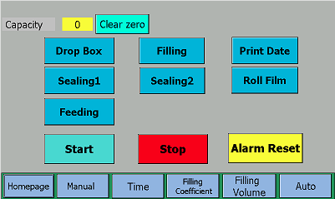
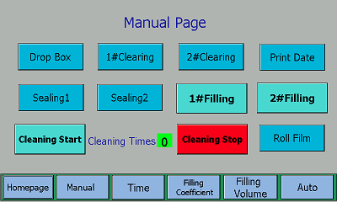
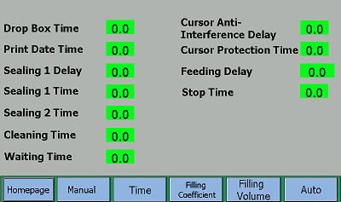

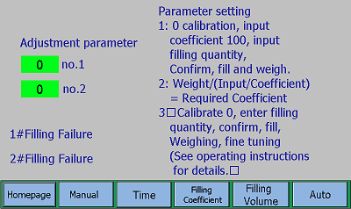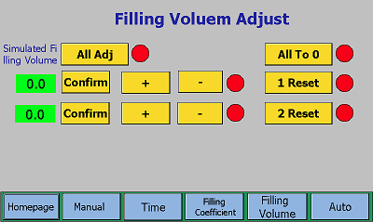
Chinese page
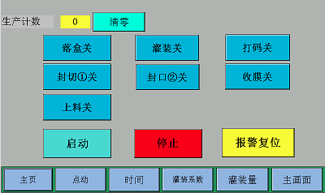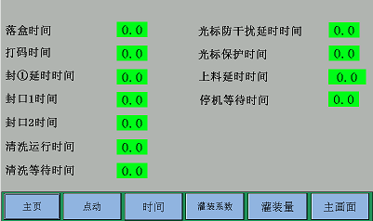
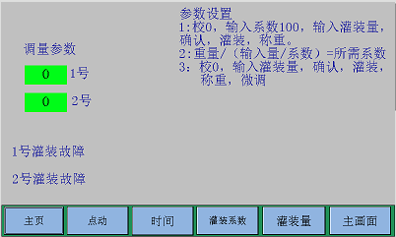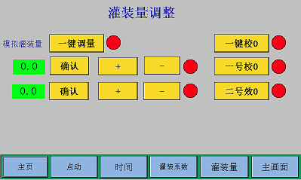

PLC circuit diagram input area:
10.0 Host running detection proximity switch
I0.1 Emergency stop switch
I0.2 Filling①Magnetic switch
I0.3 Filling ②Magnetic switch
I0.4 Membrane cursor detection photoelectric switch
I0.5 Ribbon coding groove switch
I0.6 External motor supply liquid level detection
I0.7 Spare
I1.0 Filling ① step-by-step volume adjustment proximity switch
I1.1 Filling ② step adjustment volume proximity switch
I1.2 Air pressure protection switch
I1.3 Falling cup detection magnetic control protection switch

PLC circuit output area:
Q0.0 step adjustment ①
Q0.1 Step adjustment ②
Q0.2 Running the main motor
Q0.3 External feeding motor
Q0.4 Winding motor
Q0.5 Drop box cylinder
Q0.6 Adjust the running direction of the stepping motor
Q0.7 Filling ① cylinder
Q1.0 Filling ② cylinder
Q1.1 Coding cylinder

